Quarterly Report – Public Page

Date of Report: 9th Quarterly Report, December 23, 2024
Contract Number: 693JK32210001POTA
Prepared for: Government Agency: DOT and Co-funders
Project Title: Developing Corrosion Control Monitoring Technology for Hazardous Liquid Breakout Tanks
Prepared by: Pipeline Research Council International, Inc.
Contact Information: Janie Norton, jnorton@prci.org 703-205-1600 ext: 105
For quarterly period ending: December 31, 2024

1: Items Completed During this Quarterly Period:

Item  # | Task  # | Activity/Deliverable | Title | Federal Cost | Cost Share
20 | 5 | Quarterly Project Management & Status Update Reporting | Submit 9th quarterly report | $0 | $0

2: Items Not Completed During this Quarterly Period:

Item  # | Task  # | Activity/Deliverable | Title | Federal Cost | Cost Share
 |  | None

3: Project Financial Tracking During this Quarterly Period:

Note that this chart reflects Federal share only.

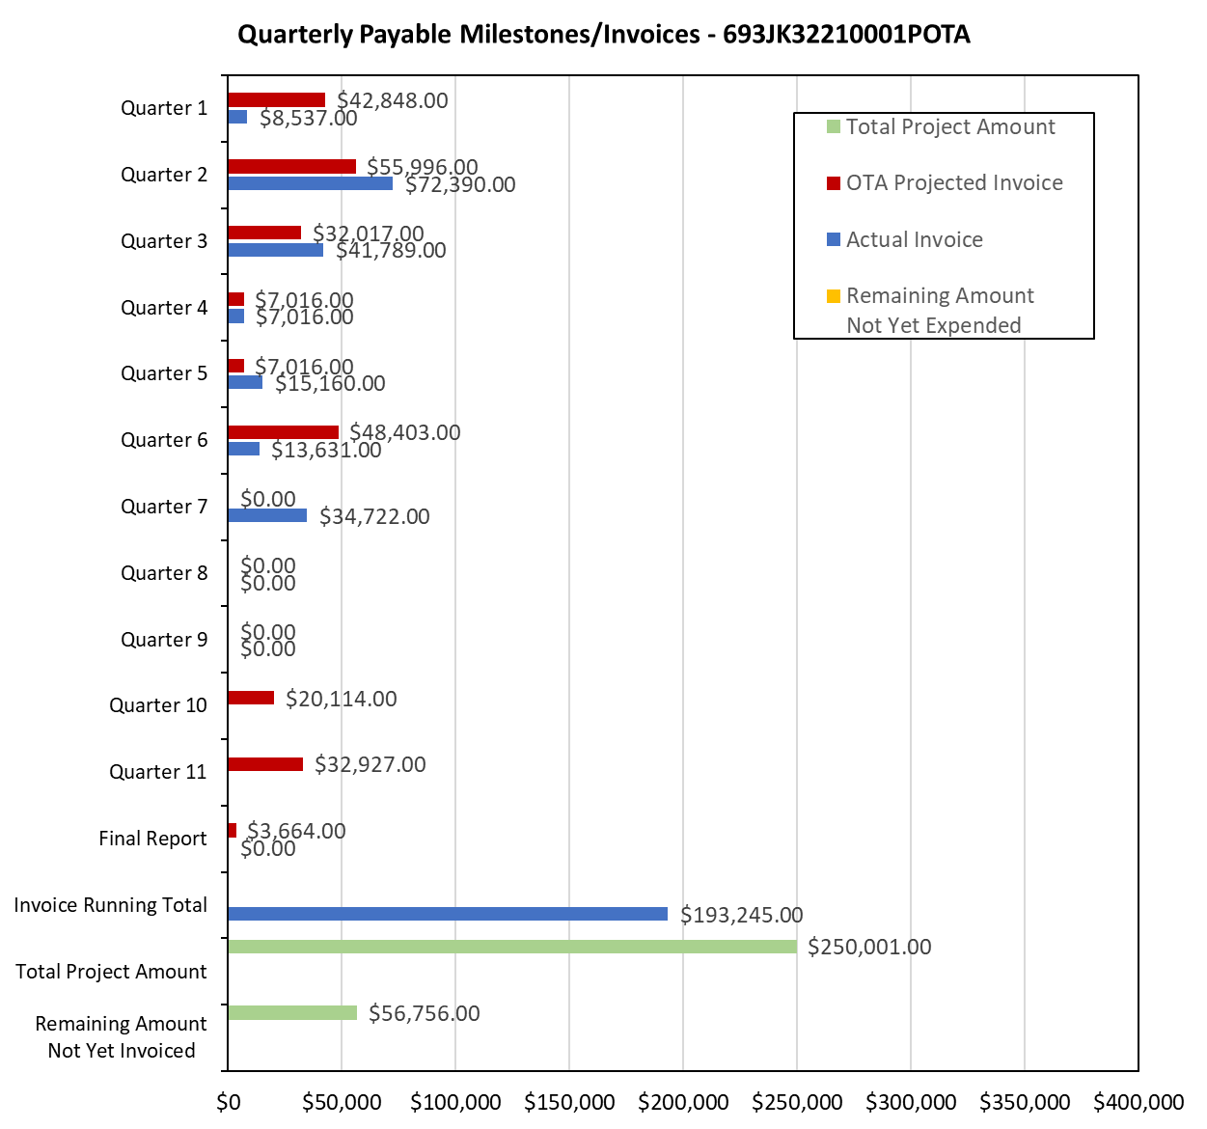

4: Project Technical Status:

Item 20, Task 5 ⎯ Quarterly Project Management & Status Update Reporting. Submit 9th quarterly report: The 9th quarter project meeting was held on December 4, 2024. This item has been completed. This item links to items 10 and 12 in Attachment 1 Team Project Activities. This item also links to item 10 in Attachment 2 Project Deliverables.

5: Project Schedule:

The project is behind schedule, and a 9-month no-cost extension request was submitted and approved. The project is on-track as per the revised deliverable schedule.

